**Daily Scrum or Standup Meeting**

Team name: Team 08

Scrum Master: Zion Steiner

Date: Nov 15

|  |  |  |  |
| --- | --- | --- | --- |
| **Team Member** | **What did you do since the last Scrum?** | **What do you plan to do before the next scrum?** | **What obstacles do you have?** |
| Hannah Howell | * Finished up Little Tweaks | * Begin working on enter_local_code page | * TechCom Presentation * Grading CS 1 Assignments * Husband still sick |
| Garrett Johnson | * Researched and created functional QR codes for auctions and items | * Make dedicated QR code pages to be printed or displayed on a projector * Implement auction publishing button | * Tech comm presentation |
| Zion Steiner | * Finished unit tests for view participants page | * Change cards to v-data-table on bid_view | * Other homework |
| Tristan Thomas | * Handled multiple bids at the same time * Handled when a bid is deleted and a new bid is placed at the same time | * Reformat everything for mobile | * Tech Presentation * OS program to write * Algorithms HW * Linear Algebra HW |
| N/A |  |  |  |

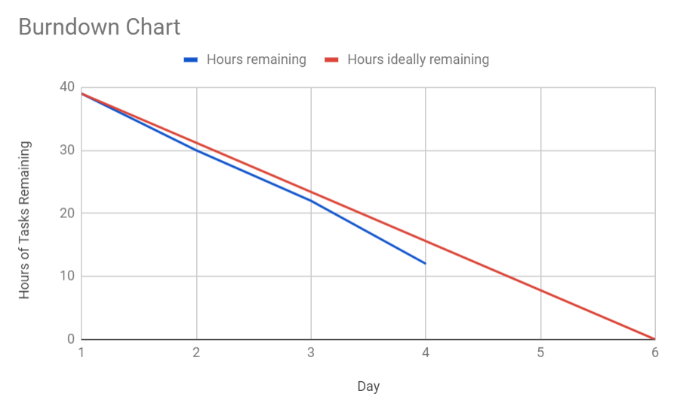

# Screenshot of your project board

